Water Crisis
Directions: Using the graphs and maps, answer the following questions.
Part 1:
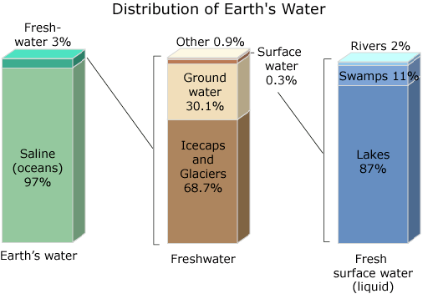
1.According to the bar graphs in Figure 1, what percentage of the earth’s water is fresh water?

2. What do these three divided bar graphs tell you about where the Earth’s fresh water resides?

Figure 1. Distribution of earth’s water.

Part 2:
Physical water scarcity refers to the lack of water to meet domestic, industrial, and agricultural needs. Areas of physical water scarcity are shown in red on the map in Figure 2 below. Economic water scarcity means that an area or country has insufficient financial resources to deliver safe, clean water to those areas that need it for drinking or agriculture. Areas of economic water scarcity are shown in orange in Figure 2.
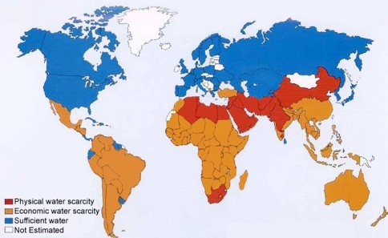
Figure 2. Global map of water scarcity in 2006.
Answer questions 3-8 based on information from the map in Figure 2.
- Name two countries in Asia that are experiencing physical water scarcity.

- What would you predict the climate to be in these areas and why?

- Name 2 countries in Asia that are experiencing economic water scarcity.

Part 3:
When water is taken from a natural source for human use, it is called “water withdrawal.”. Countries that withdraw a high percentage of their available fresh water are said to be under “freshwater stress” and are in danger of becoming considered "water scarce." In the map in Figure 3, the light orange represents mild freshwater stress and the darker orange represents extreme fresh water stress. Blue areas are considered to be free from freshwater stress.
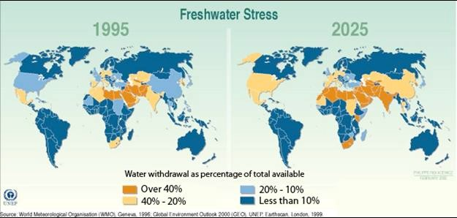
Figure 3. Global map of freshwater stress, 1995 and 2025 (predicted).

- Compare the two maps above, showing freshwater stress from the year 1995 and projected to the year 2025. What are the changes that you see happening in Asia?

Part 4:

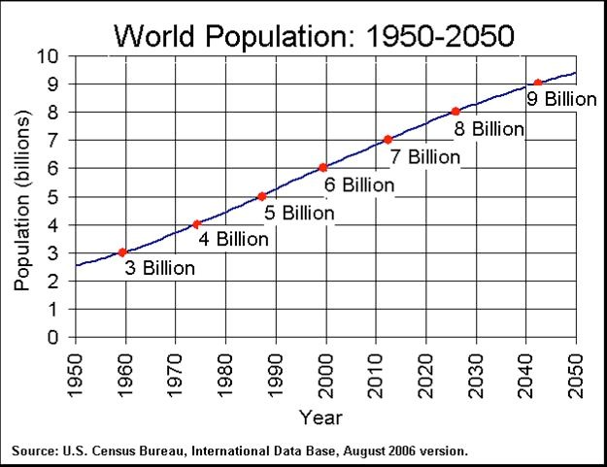
- In Figure 4, what trend do you see in for the global population?

- What would you predict the global population to be in 2060? Justify your prediction.

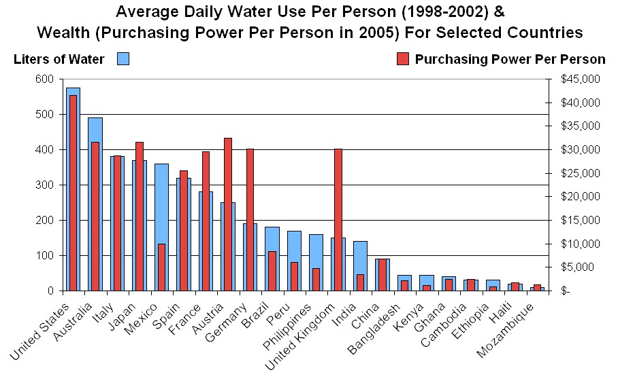
Figure 4. World population from 1950 to 2050 (predicted).

Figure 5. Average daily water use per person and wealth.
- According to Figure 5, does there seem to be a relationship (correlation) between a country’s wealth and their average daily water consumption? If so, what is the relationship?

- Based on what you know about the purchasing power and population of China and India, predict what will happen to their average daily water use per person.

